

**School of Comp. Science**

**Department of Cybernetics**

**GRAPHICS & ANIMATION**

**TOOLS LAB FILE**

**Submitted By Under Guidance of**

**Pranay Gaur Dr. Durgansh Sharma**

**B.Tech CSE-OSSOS Associate Professor**

**500062466 Dept. of Cybernetics**

# Experiment 3

Aim: Design of Google Logo using GIMP.

Step 1: Open a new GIMP file. Step 2: Add a new white layer.

Step 3: Add text “G” to the layer, set its font and size.

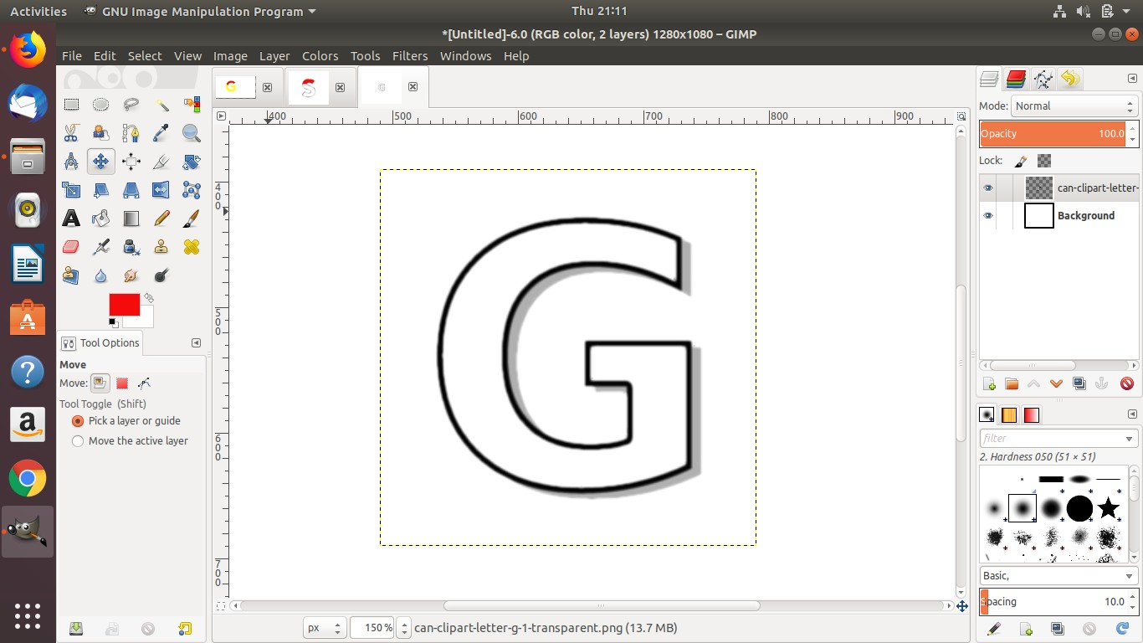

**FIGURE 1: G LETTER FOR GOOGLE LOGO**

Step 4: Use fuzzy select tool to select the contigous region and remove the outlie of the “G” letter.

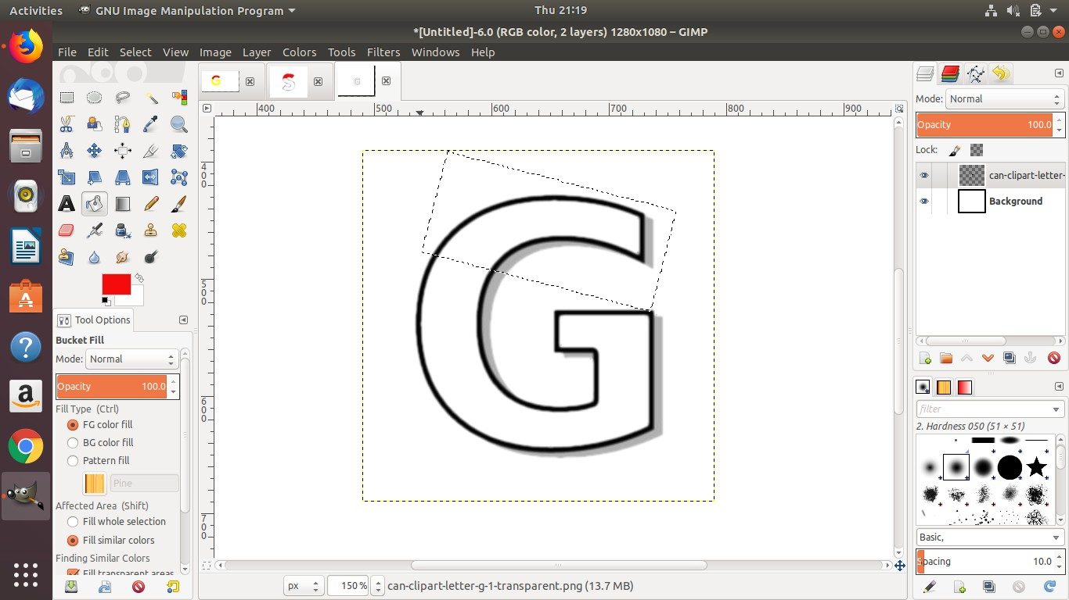

**FIGURE 2: CONFIGURING BORDER OF LETTER**

Step 5: Go to Edit and add border of min px. Step 6: Use Pencil to make regions.

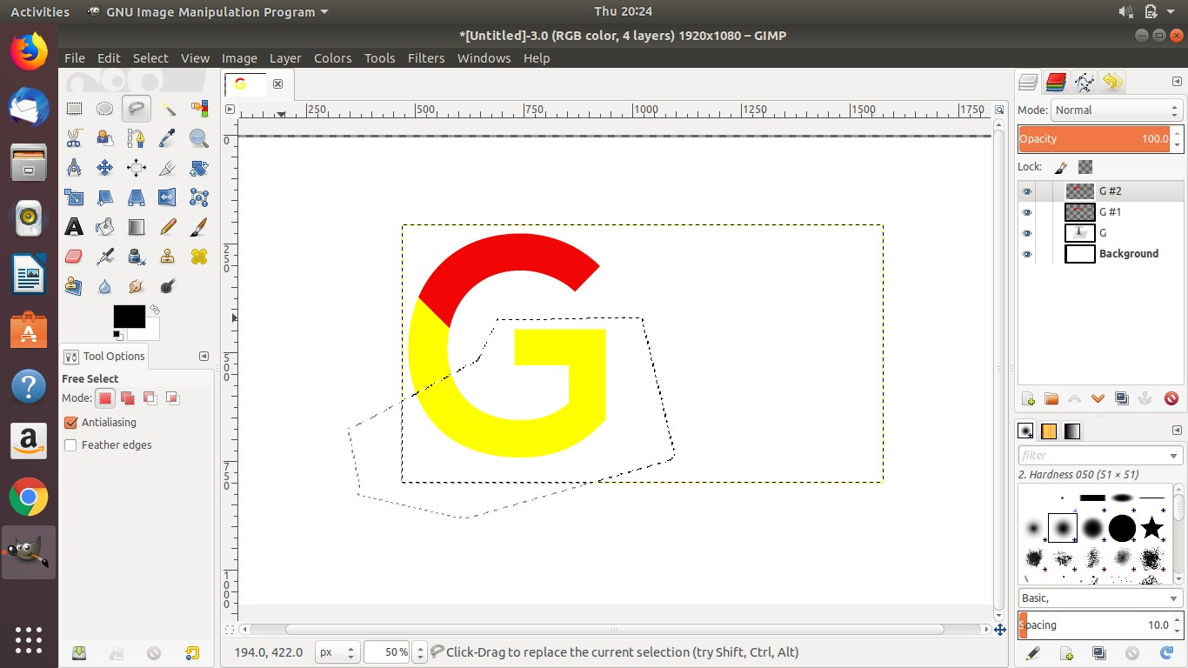

**FIGURE 17 REGION PAINTED IN RED**

Step 7: Use bucket tool to fill regions with selected foreground color.

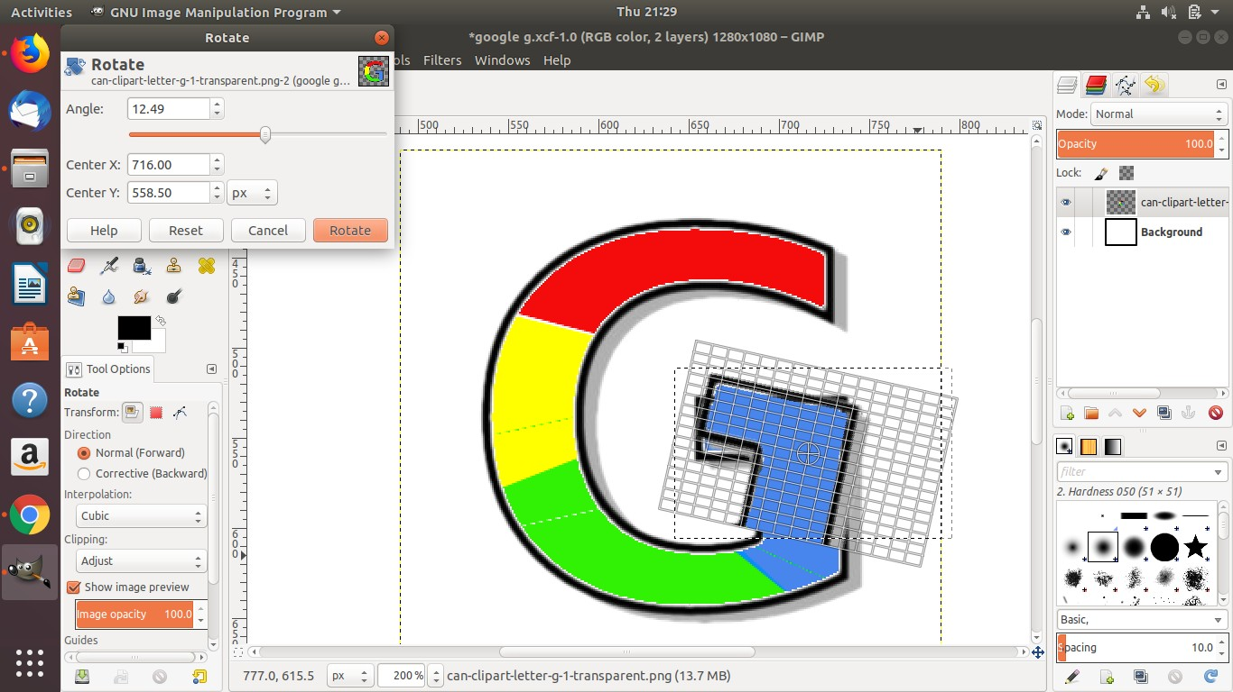

**FIGURE 3: FILLING NEXT REGIONS**



Figure 4: Final Output